Januari

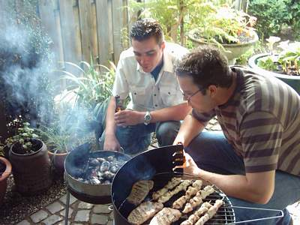

Det vleis zuut d’r good oet op ooze bbq!

1__________________ 11_________________ 21_________________
___________________ ___________________ ___________________
___________________ ___________________ ___________________
2__________________ 12_________________ 22_________________
___________________ ___________________ ___________________
___________________ ___________________ ___________________
3__________________ 13_________________ 23_________________
___________________ ___________________ ___________________
___________________ ___________________ ___________________
4__________________ 14_________________ 24_________________
___________________ ___________________ ___________________
___________________ ___________________ ___________________
5__________________ 15_________________ 25_________________
___________________ ___________________ ___________________
___________________ ___________________ ___________________
6__________________ 16_________________ 26_________________
___________________ ___________________ ___________________
___________________ ___________________ ___________________
7__________________ 17_________________ 27_________________
___________________ ___________________ ___________________
___________________ ___________________ ___________________
8__________________ 18_________________ 28_________________
___________________ ___________________ ___________________
___________________ ___________________ ___________________
9__________________ 19_________________ 29_________________
___________________ ___________________ ___________________
___________________ ___________________ ___________________
10_________________ 20_________________ 30_________________
___________________ ___________________ ___________________
___________________ ___________________ ___________________
31_________________
___________________
___________________

februari

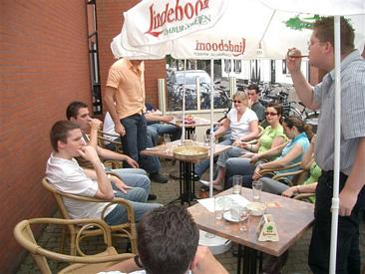

Energie indrinke veur de Hel van ‘t Vlootbachtal!

1__________________ 10_________________ 20_________________
___________________ ___________________ ___________________
___________________ ___________________ ___________________
2__________________ 11_________________ 21_________________
___________________ ___________________ ___________________
___________________ ___________________ ___________________
3__________________ 12_________________ 22_________________
___________________ ___________________ ___________________
___________________ ___________________ ___________________
4__________________ 13_________________ 23_________________
___________________ ___________________ ___________________
___________________ ___________________ ___________________
5__________________ 14_________________ 24_________________
___________________ ___________________ ___________________
___________________ ___________________ ___________________
6__________________ 15_________________ 25_________________
___________________ ___________________ ___________________
___________________ ___________________ ___________________
7__________________ 16_________________ 26_________________
___________________ ___________________ ___________________
___________________ ___________________ ___________________
8__________________ 17_________________ 27_________________
___________________ ___________________ ___________________
___________________ ___________________ ___________________
9__________________ 18_________________ 28_________________
___________________ ___________________ ___________________
___________________ ___________________ ___________________
10_________________ 19_________________ ___________________
___________________ ___________________ ___________________
___________________ ___________________ ___________________

maart

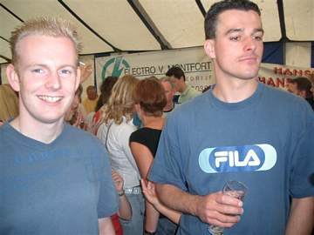

Jaojao, det beer smaak good!

1__________________ 11_________________ 21_________________
___________________ ___________________ ___________________
___________________ ___________________ ___________________
2__________________ 12_________________ 22_________________
___________________ ___________________ ___________________
___________________ ___________________ ___________________
3__________________ 13_________________ 23_________________
___________________ ___________________ ___________________
___________________ ___________________ ___________________
4__________________ 14_________________ 24_________________
___________________ ___________________ ___________________
___________________ ___________________ ___________________
5__________________ 15_________________ 25_________________
___________________ ___________________ ___________________
___________________ ___________________ ___________________
6__________________ 16_________________ 26_________________
___________________ ___________________ ___________________
___________________ ___________________ ___________________
7__________________ 17_________________ 27_________________
___________________ ___________________ ___________________
___________________ ___________________ ___________________
8__________________ 18_________________ 28_________________
___________________ ___________________ ___________________
___________________ ___________________ ___________________
9__________________ 19_________________ 29_________________
___________________ ___________________ ___________________
___________________ ___________________ ___________________
10_________________ 20_________________ 30_________________
___________________ ___________________ ___________________
___________________ ___________________ ___________________
31_________________
___________________
___________________

april

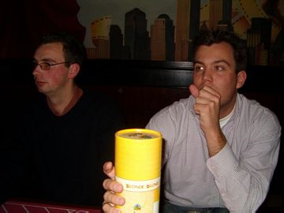

Oetaete biej de vogel!

1__________________ 11_________________ 21_________________
___________________ ___________________ ___________________
___________________ ___________________ ___________________
2__________________ 12_________________ 22_________________
___________________ ___________________ ___________________
___________________ ___________________ ___________________
3__________________ 13_________________ 23_________________
___________________ ___________________ ___________________
___________________ ___________________ ___________________
4__________________ 14_________________ 24_________________
___________________ ___________________ ___________________
___________________ ___________________ ___________________
5__________________ 15_________________ 25_________________
___________________ ___________________ ___________________
___________________ ___________________ ___________________
6__________________ 16_________________ 26_________________
___________________ ___________________ ___________________
___________________ ___________________ ___________________
7__________________ 17_________________ 27_________________
___________________ ___________________ ___________________
___________________ ___________________ ___________________
8__________________ 18_________________ 28_________________
___________________ ___________________ ___________________
___________________ ___________________ ___________________
9__________________ 19_________________ 29_________________
___________________ ___________________ ___________________
___________________ ___________________ ___________________
10_________________ 20_________________ 30_________________
___________________ ___________________ ___________________
___________________ ___________________ ___________________

mei

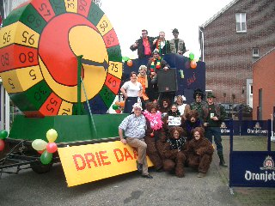

3 daag priezesjlaag!

1__________________ 11_________________ 21_________________
___________________ ___________________ ___________________
___________________ ___________________ ___________________
2__________________ 12_________________ 22_________________
___________________ ___________________ ___________________
___________________ ___________________ ___________________
3__________________ 13_________________ 23_________________
___________________ ___________________ ___________________
___________________ ___________________ ___________________
4__________________ 14_________________ 24_________________
___________________ ___________________ ___________________
___________________ ___________________ ___________________
5__________________ 15_________________ 25_________________
___________________ ___________________ ___________________
___________________ ___________________ ___________________
6__________________ 16_________________ 26_________________
___________________ ___________________ ___________________
___________________ ___________________ ___________________
7__________________ 17_________________ 27_________________
___________________ ___________________ ___________________
___________________ ___________________ ___________________
8__________________ 18_________________ 28_________________
___________________ ___________________ ___________________
___________________ ___________________ ___________________
9__________________ 19_________________ 29_________________
___________________ ___________________ ___________________
___________________ ___________________ ___________________
10_________________ 20_________________ 30_________________
___________________ ___________________ ___________________
___________________ ___________________ ___________________
31_________________
___________________
___________________

juni

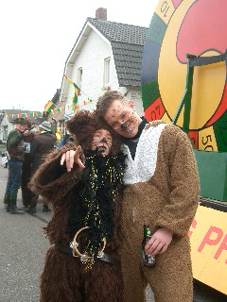

‘T woor eine romantische vastelaovendj aafgelaupe jaor!

1__________________ 11_________________ 21_________________
___________________ ___________________ ___________________
___________________ ___________________ ___________________
2__________________ 12_________________ 22_________________
___________________ ___________________ ___________________
___________________ ___________________ ___________________
3__________________ 13_________________ 23_________________
___________________ ___________________ ___________________
___________________ ___________________ ___________________
4__________________ 14_________________ 24_________________
___________________ ___________________ ___________________
___________________ ___________________ ___________________
5__________________ 15_________________ 25_________________
___________________ ___________________ ___________________
___________________ ___________________ ___________________
6__________________ 16_________________ 26_________________
___________________ ___________________ ___________________
___________________ ___________________ ___________________
7__________________ 17_________________ 27_________________
___________________ ___________________ ___________________
___________________ ___________________ ___________________
8__________________ 18_________________ 28_________________
___________________ ___________________ ___________________
___________________ ___________________ ___________________
9__________________ 19_________________ 29_________________
___________________ ___________________ ___________________
___________________ ___________________ ___________________
10_________________ 20_________________ 30_________________
___________________ ___________________ ___________________
___________________ ___________________ ___________________

juli



Alles onger controle!

1__________________ 11_________________ 21_________________
___________________ ___________________ ___________________
___________________ ___________________ ___________________
2__________________ 12_________________ 22_________________
___________________ ___________________ ___________________
___________________ ___________________ ___________________
3__________________ 13_________________ 23_________________
___________________ ___________________ ___________________
___________________ ___________________ ___________________
4__________________ 14_________________ 24_________________
___________________ ___________________ ___________________
___________________ ___________________ ___________________
5__________________ 15_________________ 25_________________
___________________ ___________________ ___________________
___________________ ___________________ ___________________
6__________________ 16_________________ 26_________________
___________________ ___________________ ___________________
___________________ ___________________ ___________________
7__________________ 17_________________ 27_________________
___________________ ___________________ ___________________
___________________ ___________________ ___________________
8__________________ 18_________________ 28_________________
___________________ ___________________ ___________________
___________________ ___________________ ___________________
9__________________ 19_________________ 29_________________
___________________ ___________________ ___________________
___________________ ___________________ ___________________
10_________________ 20_________________ 30_________________
___________________ ___________________ ___________________
___________________ ___________________ ___________________
31_________________
___________________
___________________

augustus



De eupening in Melick waas geslaag!

1__________________ 11_________________ 21_________________
___________________ ___________________ ___________________
___________________ ___________________ ___________________
2__________________ 12_________________ 22_________________
___________________ ___________________ ___________________
___________________ ___________________ ___________________
3__________________ 13_________________ 23_________________
___________________ ___________________ ___________________
___________________ ___________________ ___________________
4__________________ 14_________________ 24_________________
___________________ ___________________ ___________________
___________________ ___________________ ___________________
5__________________ 15_________________ 25_________________
___________________ ___________________ ___________________
___________________ ___________________ ___________________
6__________________ 16_________________ 26_________________
___________________ ___________________ ___________________
___________________ ___________________ ___________________
7__________________ 17_________________ 27_________________
___________________ ___________________ ___________________
___________________ ___________________ ___________________
8__________________ 18_________________ 28_________________
___________________ ___________________ ___________________
___________________ ___________________ ___________________
9__________________ 19_________________ 29_________________
___________________ ___________________ ___________________
___________________ ___________________ ___________________
10_________________ 20_________________ 30_________________
___________________ ___________________ ___________________
___________________ ___________________ ___________________
31_________________
___________________
___________________

september



Kabouter Plop en Grote Smurf!

1__________________ 11_________________ 21_________________
___________________ ___________________ ___________________
___________________ ___________________ ___________________
2__________________ 12_________________ 22_________________
___________________ ___________________ ___________________
___________________ ___________________ ___________________
3__________________ 13_________________ 23_________________
___________________ ___________________ ___________________
___________________ ___________________ ___________________
4__________________ 14_________________ 24_________________
___________________ ___________________ ___________________
___________________ ___________________ ___________________
5__________________ 15_________________ 25_________________
___________________ ___________________ ___________________
___________________ ___________________ ___________________
6__________________ 16_________________ 26_________________
___________________ ___________________ ___________________
___________________ ___________________ ___________________
7__________________ 17_________________ 27_________________
___________________ ___________________ ___________________
___________________ ___________________ ___________________
8__________________ 18_________________ 28_________________
___________________ ___________________ ___________________
___________________ ___________________ ___________________
9__________________ 19_________________ 29_________________
___________________ ___________________ ___________________
___________________ ___________________ ___________________
10_________________ 20_________________ 30_________________
___________________ ___________________ ___________________
___________________ ___________________ ___________________

oktober

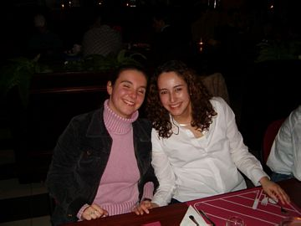

Ff lache nao ‘t veugelke!

1__________________ 11_________________ 21_________________
___________________ ___________________ ___________________
___________________ ___________________ ___________________
2__________________ 12_________________ 22_________________
___________________ ___________________ ___________________
___________________ ___________________ ___________________
3__________________ 13_________________ 23_________________
___________________ ___________________ ___________________
___________________ ___________________ ___________________
4__________________ 14_________________ 24_________________
___________________ ___________________ ___________________
___________________ ___________________ ___________________
5__________________ 15_________________ 25_________________
___________________ ___________________ ___________________
___________________ ___________________ ___________________
6__________________ 16_________________ 26_________________
___________________ ___________________ ___________________
___________________ ___________________ ___________________
7__________________ 17_________________ 27_________________
___________________ ___________________ ___________________
___________________ ___________________ ___________________
8__________________ 18_________________ 28_________________
___________________ ___________________ ___________________
___________________ ___________________ ___________________
9__________________ 19_________________ 29_________________
___________________ ___________________ ___________________
___________________ ___________________ ___________________
10_________________ 20_________________ 30_________________
___________________ ___________________ ___________________
___________________ ___________________ ___________________
31_________________
___________________
___________________

november

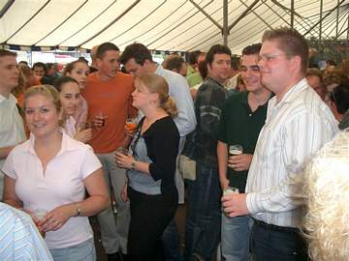

Luukse mèrt in Lin!

1__________________ 11_________________ 21_________________
___________________ ___________________ ___________________
___________________ ___________________ ___________________
2__________________ 12_________________ 22_________________
___________________ ___________________ ___________________
___________________ ___________________ ___________________
3__________________ 13_________________ 23_________________
___________________ ___________________ ___________________
___________________ ___________________ ___________________
4__________________ 14_________________ 24_________________
___________________ ___________________ ___________________
___________________ ___________________ ___________________
5__________________ 15_________________ 25_________________
___________________ ___________________ ___________________
___________________ ___________________ ___________________
6__________________ 16_________________ 26_________________
___________________ ___________________ ___________________
___________________ ___________________ ___________________
7__________________ 17_________________ 27_________________
___________________ ___________________ ___________________
___________________ ___________________ ___________________
8__________________ 18_________________ 28_________________
___________________ ___________________ ___________________
___________________ ___________________ ___________________
9__________________ 19_________________ 29_________________
___________________ ___________________ ___________________
___________________ ___________________ ___________________
10_________________ 20_________________ 30_________________
___________________ ___________________ ___________________
___________________ ___________________ ___________________

december

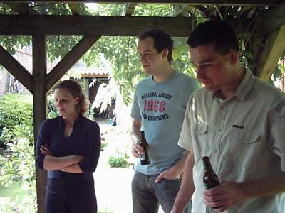

In aafwachting op ein lekker stukske vleis oppe bbq!

1__________________ 11_________________ 21_________________
___________________ ___________________ ___________________
___________________ ___________________ ___________________
2__________________ 12_________________ 22_________________
___________________ ___________________ ___________________
___________________ ___________________ ___________________
3__________________ 13_________________ 23_________________
___________________ ___________________ ___________________
___________________ ___________________ ___________________
4__________________ 14_________________ 24_________________
___________________ ___________________ ___________________
___________________ ___________________ ___________________
5__________________ 15_________________ 25_________________
___________________ ___________________ ___________________
___________________ ___________________ ___________________
6__________________ 16_________________ 26_________________
___________________ ___________________ ___________________
___________________ ___________________ ___________________
7__________________ 17_________________ 27_________________
___________________ ___________________ ___________________
___________________ ___________________ ___________________
8__________________ 18_________________ 28_________________
___________________ ___________________ ___________________
___________________ ___________________ ___________________
9__________________ 19_________________ 29_________________
___________________ ___________________ ___________________
___________________ ___________________ ___________________
10_________________ 20_________________ 30_________________
___________________ ___________________ ___________________
___________________ ___________________ ___________________
31_________________
___________________
___________________

